IMU MONITERED SPEED CONTROL MOBILE ROBOT
Introduction
In the realm of robotics, maneuverability and precision are paramount. This report details the design and implementation of a mobile robot that leverages the capabilities of an Arduino Mega microcontroller, an Inertial Measurement Unit (IMU) sensor, and L293D motor drivers to achieve speed control based on sensor feedback.
Components
- Arduino Mega: The Arduino Mega serves as the brain of the robot, coordinating sensor data acquisition, motor control calculations, and signal transmission to the motor drivers. Its high pin count and processing power make it suitable for handling multiple sensors and actuators.
- IMU Sensor: The IMU sensor, often comprising an accelerometer, gyroscope, and magnetometer, provides real-time data on the robot's orientation (tilt, roll, yaw) and acceleration. This information is crucial for maintaining stability and regulating speed based on inclines or declines. Common IMU options include the MPU-6050 and LSM303D.
- L293D Motor Drivers: These integrated circuits act as intermediaries between the Arduino Mega's control signals and the DC motors. They allow for bi-directional control (forward/reverse) and speed regulation using Pulse Width Modulation (PWM).
System Design
- Hardware Assembly:
  - Securely mount the Arduino Mega, IMU sensor, L293D motor drivers, DC motors, and a power supply onto a suitable chassis (e.g., acrylic, wood).
  - Connect the IMU sensor to the Arduino Mega using I2C or SPI communication protocols as per the sensor's specifications.
  - Wire the L293D motor drivers to the Arduino Mega's digital output pins for motor control signals and to the DC motors for power delivery.
  - Ensure a stable power supply to all components.
- Software Development:
  - Arduino IDE Setup: Install the Arduino IDE
  - Sensor Integration: Write code to initialize the IMU sensor, establish communication, and start reading sensor data (acceleration, orientation).
  - Wokwi: A software for simulation of various micro controller boards and sensors
  - Fritzing: An IDE specially developed for online users to check all the sensor functionalities and assemblies and acts as a compiler and flashing device too
  - Main Loop: Structure the code with a setup() function for initialization and a loop() function that continuously reads sensor data, executes the motor control and sends control signals to the motor drivers.

The working:
Wokwi:
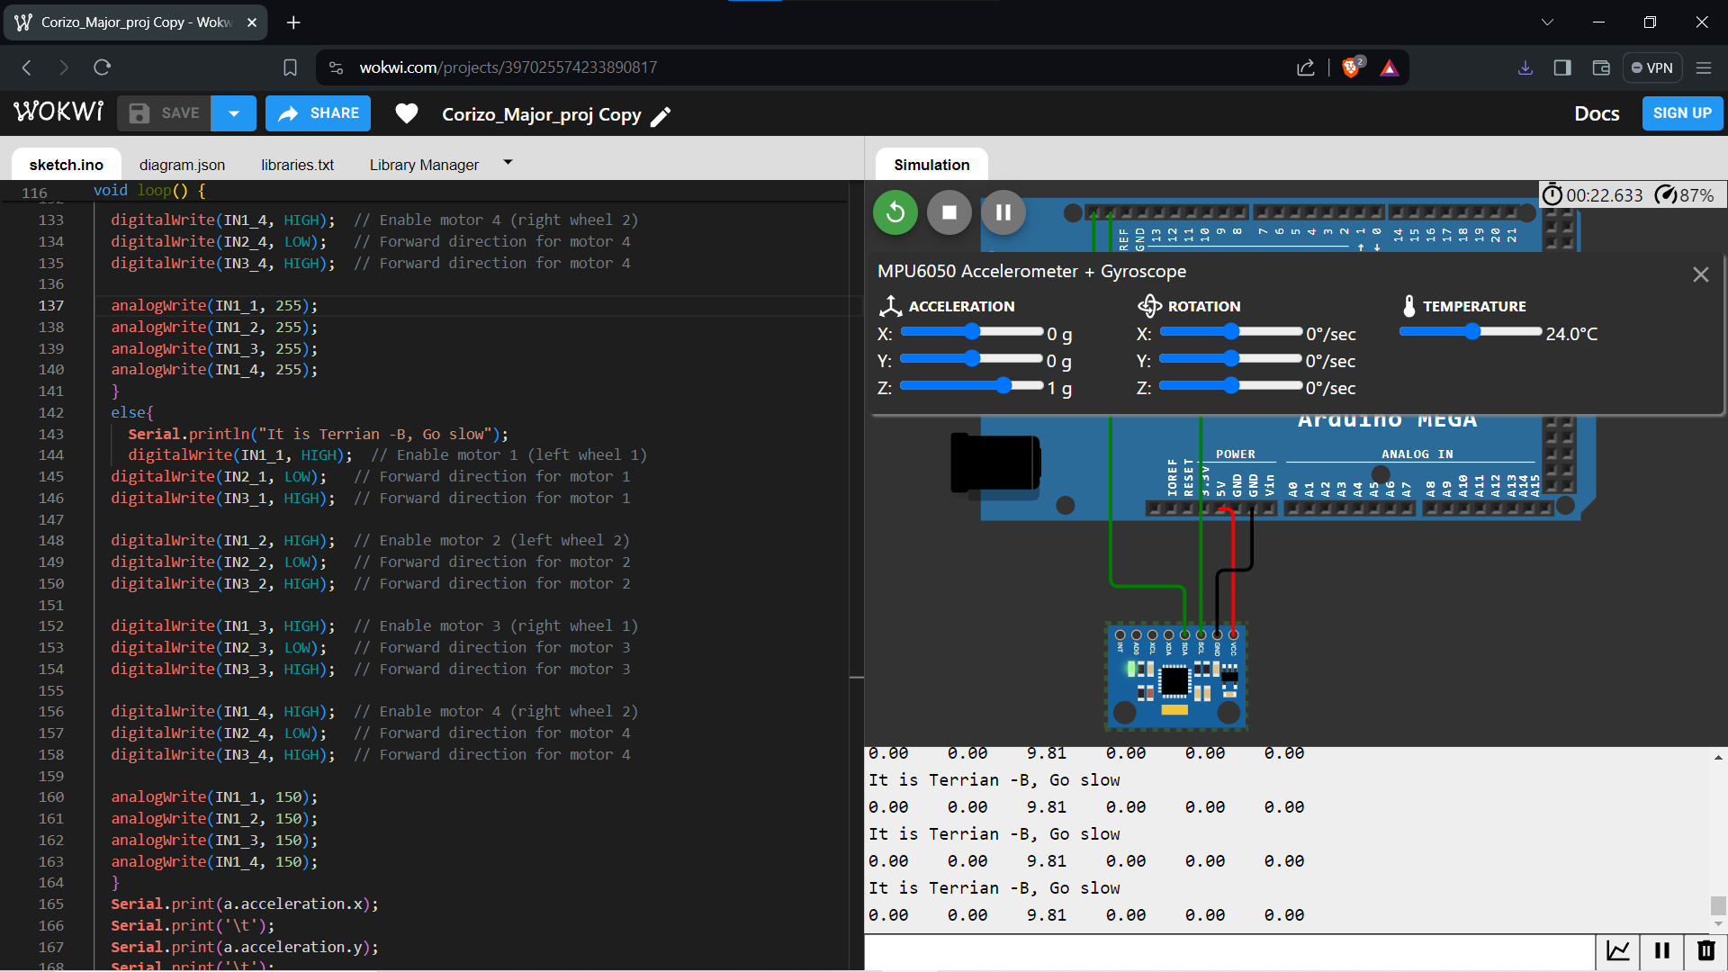
(https://wokwi.com/projects/397025574233890817)
Fritzing:
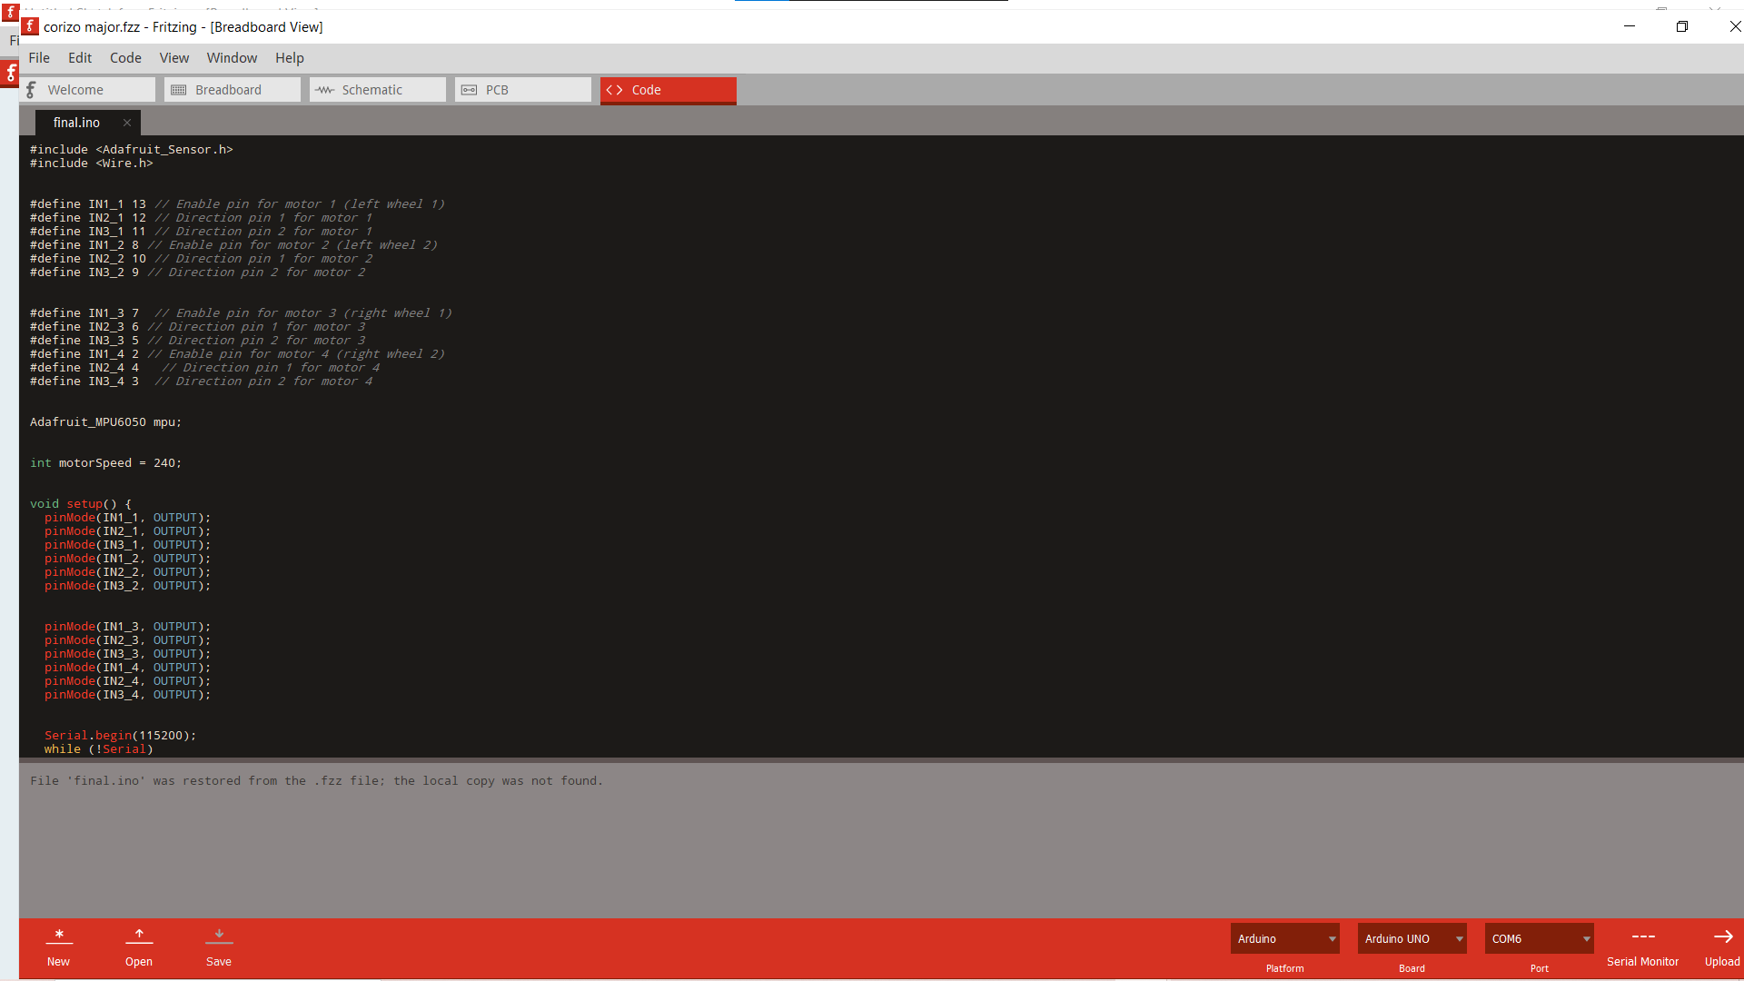
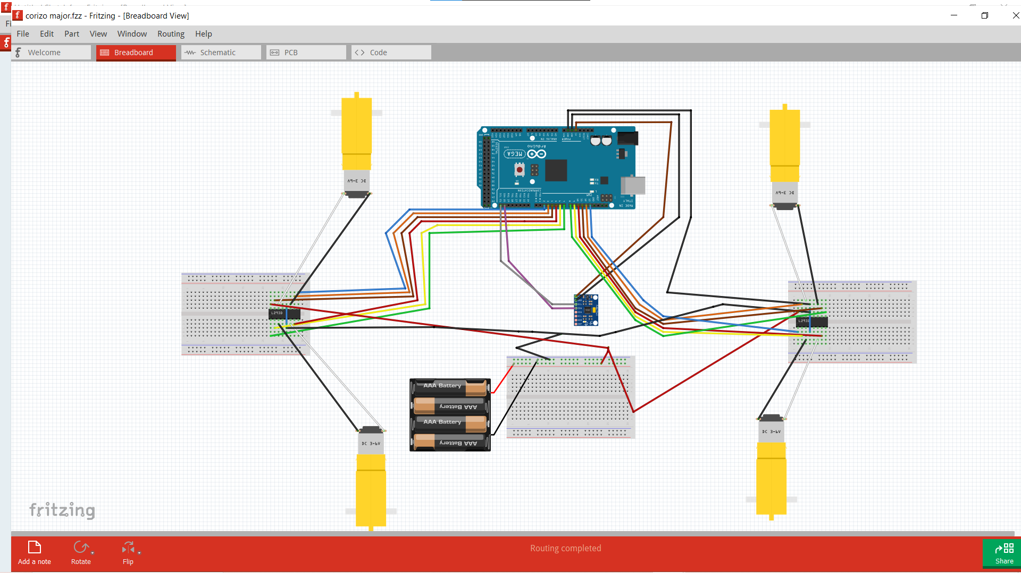
(Fritzing)
We were not able to implement our idea in just one simulator due to lack of resources available so we opted to showcase it in 2 different environments. Kindly consider it, Thank you

